Gabi’s what knots and more Newsletter
The newsletter for all things crafty and beautifying
In this flyer:
- A craftastic update
- Jamberry, Perfectly Posh, AVON
- Where to purchase and find me
Let’s get started!!!
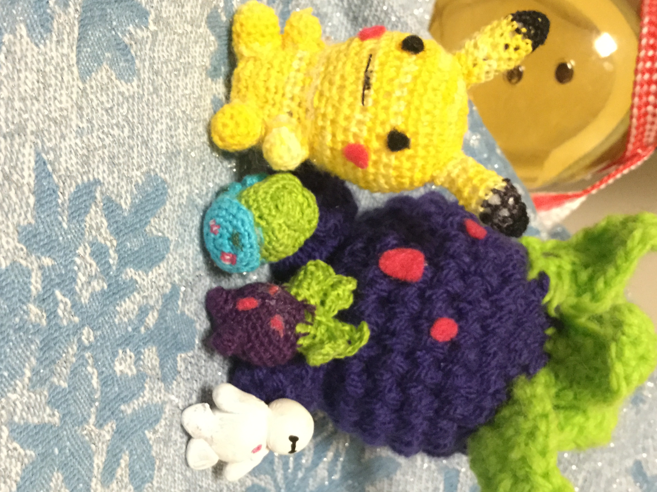Update: Hi, everyone. It’s been almost a year since I started this newsletter. I hope you have all enjoyed it and have followed along online at my shopping blog. If you’d like to have this emailed to you let me know as well.
I have a Big Announcement to make: Gabi's What Knots and More is starting up this month of February and I'll not only be selling AVON and Jamberry, but also selling my own selection of fashion accessories and jewelry, along with my handicrafts! You can see some of them featured in the picture above. Those are my minis. They aren’t for sale yet, but I’m sure they’d be a hit. In addition, to these great products, I'm now an affiliate with the natural, gluten free, vegan cosmetic line Perfectly Posh.
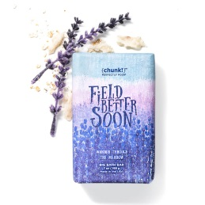
Quick Reminder: I will continue offering the customers who contact me directly free 2-day shipping on all $25 AVON orders. As well, Jamberry is always a flat fee of $5.95, but there is free shipping on your style-box subscription plus anything else you add to your order. :-)
Now let's dive into all the products available from AVON, Jamberry and Perfectly Posh.
Jamberry picks for February
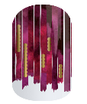
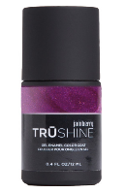
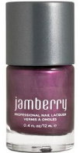
As always I love Jamberry nail wraps and my favorite. this month are the Sister's Style New York Minute ($15). In addition, I always pick two great colors in our Trushine gel and 5-free lacquer that complement the wrap I choose each month.This month I chose, as pictured, Jammin for the Lacquer and Beauty Sleep in the Trushine. Both have a nice purple hue that will match the New York Minute vinyl wrap. As always its buy 3 Get 1 free.

Perfectly Posh-All Natural Products that your skin will thank you for. :-)
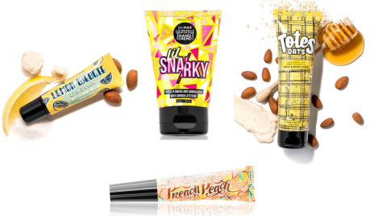
As introduced earlier, Perfectly Posh is all natural and made from essential oils and extracts of fruits and plants. They are Buy 5 Get 6th item free, unless specified. My selection of Perfectly Posh for the month of February are the following: Lil Snarky Big Fat Yummy Handcream ($9 and my favorite), Field Better Soon ($9; a nice lavender scent), Totes Oats Calming Face and Body Mask ($22; Honey and Oats scent), Lemon Wedgie (available in both a lip scrub; $14 and Balm;$5), and lastly Preach Peach Lip Oil ($15; a peachy oil that will hydrate lips)
AVON-February's I <3 A Sale Semi-Annual Event
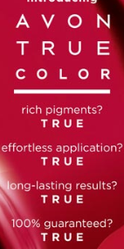
First, it’s AVON's Semi-Annual Sale; all of last year’s products are steeply discounted on pages 166-193. Check that out and see if your favorites are still available.
Makeup: Next, if you have followed along you should know that AVON rebranded their makeup line last month to AVON True Color- Truly Beautiful. Richer pigments and lasting color! Check the new formula out today. (pp 7-37)
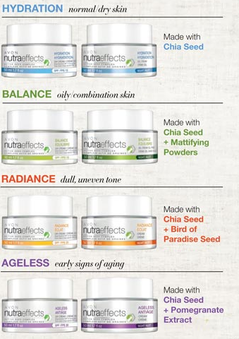
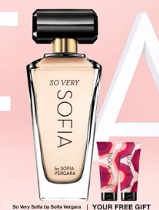
Fragrances: As always we have a great selection of fragrances (pp39-59) Some of my favorites are (For women): So Very Sofia, Today-Tomorrow-Always, Little Red Dress, Haiku, and Kyoto Flower. As well as the following fragrances for men: Black Suede Sport, Alpha, and Wild Country.
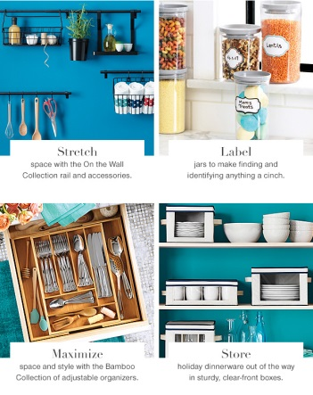
Moisturizers, Anti-Aging, and Body Creams/Lotions: If you like facial creams that not only moisturize, but protect you from the sun rays. AVON has a great selection of products for you. Our hypoallergenic facial creams are made from chia seeds and other natural oils. We carry 4 different kinds that attack 4 different skin problems-hydration, balance, ageless, and radiance. (Each for $14.99; p61) And don't forget the Anti-Aging ANEW line, in addition to our Planet Spa, Classic Skin-so-Soft, and Senses lotions products (p139-165).
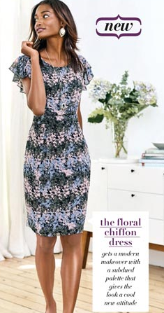
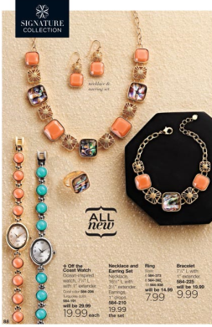
Fashion/Jewelry: In jewelry, I have to say I love the new Splash of color Collection on page 88. We also have a great selection of Easter theme jewelry as well. My favorite is the Blue Shaky Cross Necklace ($19.99 or Buy 1 Get 1 half off; p96). If you aren't interested in those products, check out the additional AVON essentials jewelry and AVON .925 Sterling Silver products. In addition, We also have empowerment statement jewelry this campaign, which 100% of proceeds go to helping women fight against domestic violence issues. (pp99-115) Lastly, in clothing, I love the Lattice Back Ruffle Top (p119), Soft Flutter Sleeve Dress (p120) and the cute mini crossbody purse (p121).
Home: I can't close until I mention all the products that AVON Living is carrying this time. There's something to organize each room of the house. Plus we have some great candles on sale too (2 for $19.99; p 136).
When are orders due? Make sure to get your orders in by February 28 with me for any of the products mentioned above. I hope you have a great February and I'll be back in March for a new set of products to share with you.
Contact Information:
If you have any questions, requesting a catalog, want a sample, or have orders, please contact me at:
Gabiscreations.weebly.com OR
Gabbys_shops@yahoo.com
Avon/Jamberry blog for discounts and more:
beautyandnails4u.wordpress.com
Visit my AVON e-store at: youravon.com/gabisbeauty

